**Scalefocus DevOps Academy**

**Azure - Lab 08 - Manage Virtual Machines**

#### **Task 1: Deploy zone-resilient Azure virtual machines by using the Azure portal and an Azure Resource Manager template**

1. **We start by selecting Virtual machines on Azure Portal.**

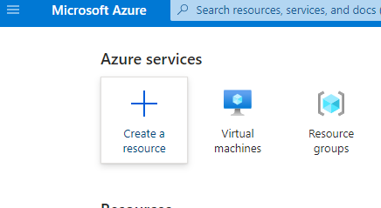

1. **Click create and select Azure Virtual machine:**

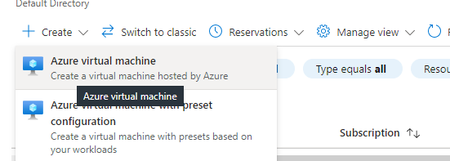

1. **In the Basic menu we configure *create a new rg with the given name, we assign the name of VM and select following options from the LAB.**
2. **In the DISK section we configure the OS disk type to premium SSD.**
3. **In Networking we configure the VN with the given info.**

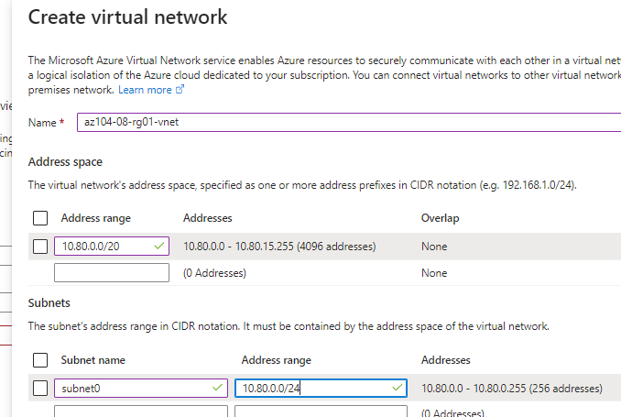

1. **In this step we create the Virtual network with the given address 10.80.0.0/20 and the subnet0 with rage 10.80.0.0/24.**
2. **After we click OK and select subnet 0 that we previously configured, we don’t change the public IP.**

|  |  |
| --- | --- |
| NIC network security group | **basic** |
| Public inbound Ports | **None** |
| Accelerated networking | **Off** |
| Place this virtual machine behind an existing load balancing solution? | **Unchecked** |

1. **On the Management Tab we select:**

|  |  |
| --- | --- |
| Patch orchestration options | **Manual updates** |

1. **In Monitoring we have to create a new diagnostics storage account, remember the name we wil need it further in the Lab. ( mine is Kochalevski )**
2. **Advanced manu we don’t change anything.**
3. **Review + Create, than Create.**
4. **On the Deployment blade click on Template:**

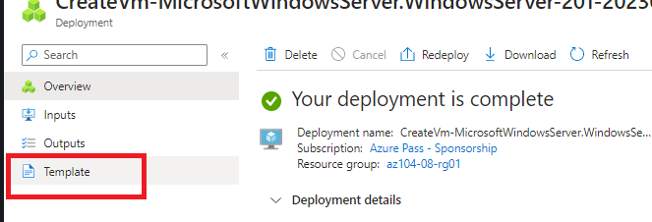

1. **Click Deploy:**

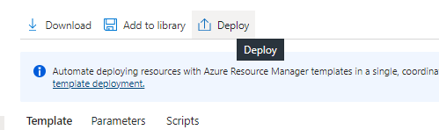

1. **On the next menu we fill the following info:**

|  |  |
| --- | --- |
| Setting | Value |
| Resource Group | **az104-08-rg01** |
| Network Interface Name | **az104-08-vm1-nic1** |
| Public IP Address Name | **az104-08-vm1-ip** |
| Virtual Machine Name, Virtual Machine Name1 | **az104-08-vm1** |
| Virtual Machine RG | **az104-08-rg01** |
| Admin Username | **Student** |
| Admin Password | **Provide a secure password** |
| Enable Hotpatching | **false** |
| Zone | **2** |

***The all others are left by default.***

1. **Review + Create, Create:**

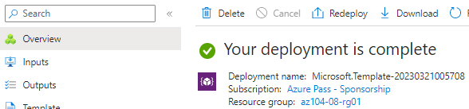

**Note: То review that the 1st task if ok you can check in virtual machines if you have successfully created two VMs.**

#### **Task 2: Configure Azure virtual machines by using virtual machine extensions**

-*In this task, you will install Windows Server Web Server role on the two Azure virtual machines you deployed in the previous task by using the Custom Script virtual machine extension.*

1. **On the Azure portal, we search for Storage accounts to find the storage account we did in the previous task.**

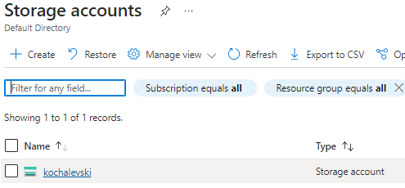

1. **From the blade menu we add a container.**

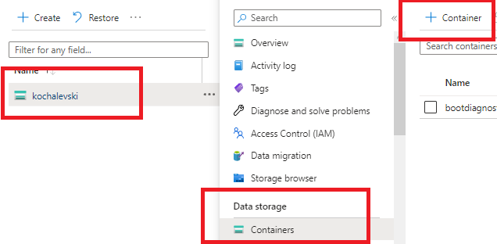

1. **On the New Container blade we fill in the following values and we click Create.**

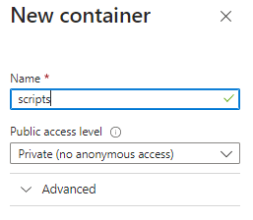

1. **In the menu choose the scripts container:**
2. **Click Upload:**

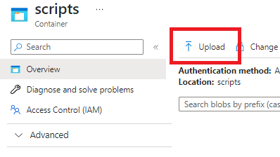

1. On the **Upload blob** blade, click the folder icon, in the **Open** dialog box, navigate to the **\Allfiles\Labs\08** folder, select **az104-08-install_IIS.ps1**, click **Open**, and back on the **Upload blob** blade, click **Upload**.

**I’ve made a pull request from GitHub to receive the file so I can upload it in the “Upload blob”**

1. In the Azure portal, search for and select **Virtual machines** and, on the **Virtual machines** blade, click **az104-08-vm0**

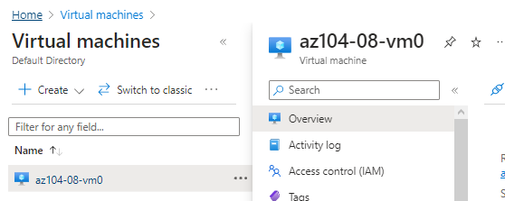

1. On the **az104-08-vm0** virtual machine blade, in the **Settings** section, click **Extensions + applications**, and the click **+ Add**.

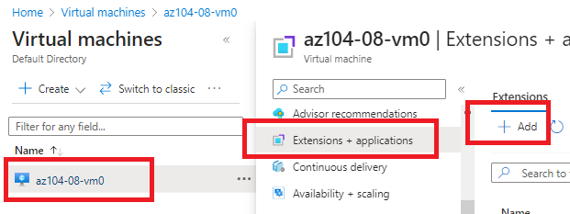

1. On the **Install an Extension** blade, click **Custom Script Extension** and then click **Next**.

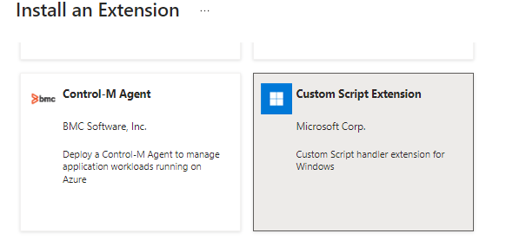

1. From the **Configure Custom Script Extension Extension** blade, click **Browse**.

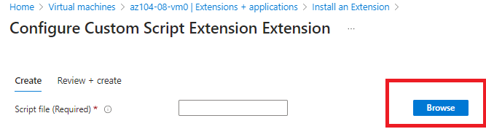

1. On the **Storage accounts** blade, click the name of the storage account into which you uploaded the **az104-08-install_IIS.ps1** script, on the **Containers** blade, click **scripts**, on the **scripts** blade, click **az104-08-install_IIS.ps1**, and then click **Select**.

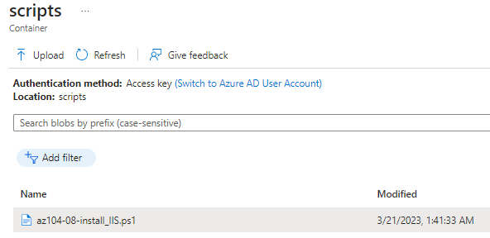

1. Back on the **Install extension** blade, click **Review + create** and, on the **Review + create** blade click **Create**.
2. In the Azure portal, search for and select **Virtual machines** and, on the **Virtual machines** blade, click **az104-08-vm1**.
3. On the **az104-08-vm1** blade, in the **Automation** section, click **Export template**.
4. On the **az104-08-vm1 - Export template** blade, click **Deploy**.
5. On the **Custom deployment** blade, click **Edit template**.
6. On the **Edit template** blade, in the section displaying the content of the template, insert the following code starting with line **20** (directly underneath the "resources": [ line):

{

"type": "Microsoft.Compute/virtualMachines/extensions",

"name": "az104-08-vm1/customScriptExtension",

"apiVersion": "2018-06-01",

"location": "[resourceGroup().location]",

"dependsOn": [

"az104-08-vm1"

],

"properties": {

"publisher": "Microsoft.Compute",

"type": "CustomScriptExtension",

"typeHandlerVersion": "1.7",

"autoUpgradeMinorVersion": true,

"settings": {

"commandToExecute": "powershell.exe Install-WindowsFeature -name Web-Server -IncludeManagementTools && powershell.exe remove-item 'C:\\inetpub\\wwwroot\\iisstart.htm' && powershell.exe Add-Content -Path 'C:\\inetpub\\wwwroot\\iisstart.htm' -Value $('Hello World from ' + $env:computername)"

}

}

},

1. Click **Save** and, back on the **Custom template** blade, click **Review + Create** and, on the **Review + Create** blade, click **Create.**
2. To verify that the Custom Script extension-based configuration was successful, navigate back on the **az104-08-vm1** blade, in the **Operations** section, click **Run command**, and, in the list of commands, click **RunPowerShellScript**.
3. On the **Run Command Script** blade, type the following and click **Run** to access the web site hosted on **az104-08-vm0**:

**Invoke-WebRequest -URI http://10.80.0.4 -UseBasicParsing**

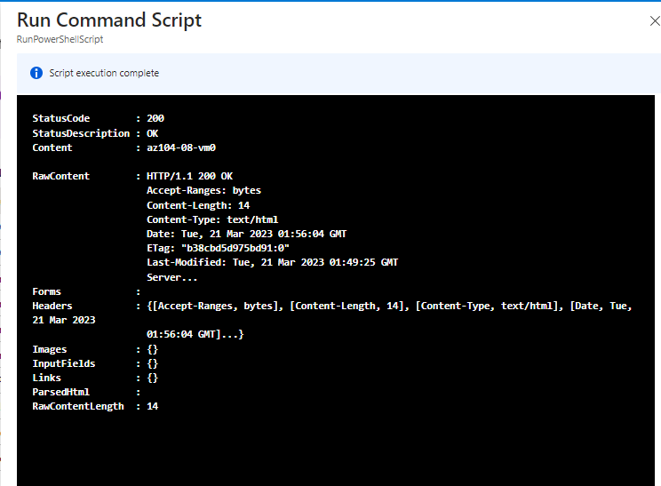

#### **Task 3: Scale compute and storage for Azure virtual machines**

**-In this task you will scale compute for Azure virtual machines by changing their size and scale their storage by attaching and configuring their data disks.**

1. In the Azure portal, search for and select **Virtual machines** and, on the **Virtual machines** blade, click **az104-08-vm0**.
2. On the **az104-08-vm0** virtual machine blade, click **Size** and set the virtual machine size to **Standard DS1_v2** and click **Resize**

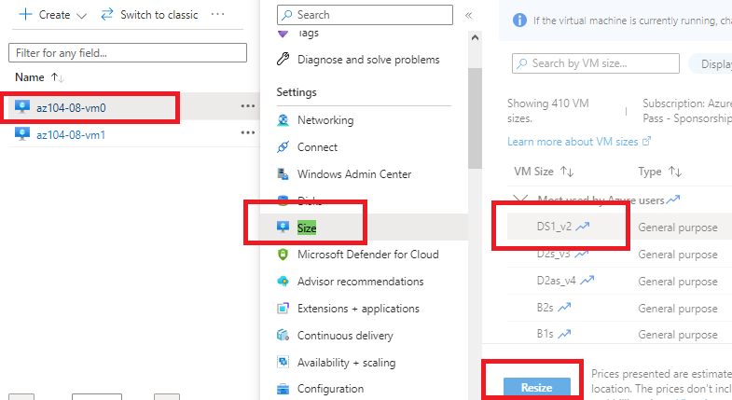

1. On the **az104-08-vm0** virtual machine blade, click **Disks**, Under **Data disks** click **+ Create and attach a new disk**.
2. Create a managed disk with the following settings (leave others with their default values):

|  |  |
| --- | --- |
| Setting | Value |
| Disk name | **az104-08-vm0-datadisk-0** |
| Storage type | **Premium SSD** |
| Size (GiB | **1024** |

1. Back on the **az104-08-vm0 - Disks** blade, Under **Data disks** click **+ Create and attach a new disk**.
2. Create a managed disk with the following settings (leave others with their default values) and Save changes:

|  |  |
| --- | --- |
| Setting | Value |
| Disk name | **az104-08-vm0-datadisk-1** |
| Storage type | **Premium SSD** |
| Size (GiB) | **1024 GiB** |

1. Back on the **az104-08-vm0 - Disks** blade, click **Save**.

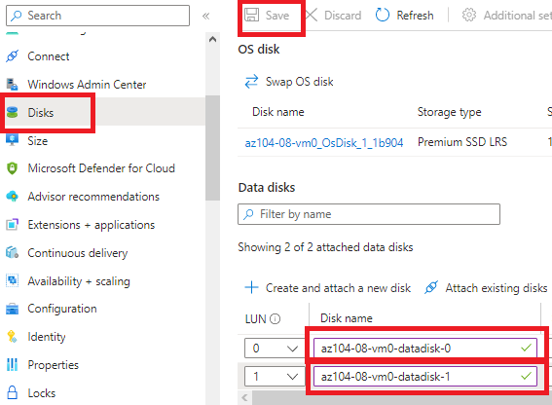

1. On the **az104-08-vm0** blade, in the **Operations** section, click **Run command**, and, in the list of commands, click **RunPowerShellScript**.
2. On the **Run Command Script** blade, type the following and click **Run** to create a drive Z: consisting of the two newly attached disks with the simple layout and fixed provisioning:

New-StoragePool -FriendlyName storagepool1 -StorageSubsystemFriendlyName "Windows Storage*" -PhysicalDisks (Get-PhysicalDisk -CanPool $true)

New-VirtualDisk -StoragePoolFriendlyName storagepool1 -FriendlyName virtualdisk1 -Size 2046GB -ResiliencySettingName Simple -ProvisioningType Fixed

Initialize-Disk -VirtualDisk (Get-VirtualDisk -FriendlyName virtualdisk1)

New-Partition -DiskNumber 4 -UseMaximumSize -DriveLetter Z

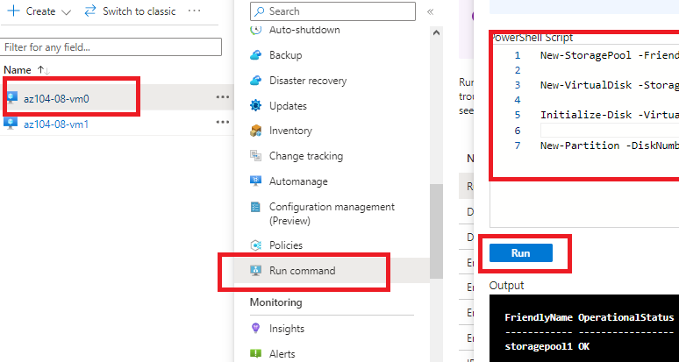

1. In the Azure portal, search for and select **Virtual machines** and, on the **Virtual machines** blade, click **az104-08-vm1**.
2. On the **az104-08-vm1** blade, in the **Automation** section, click **Export template**.
3. On the **az104-08-vm1 - Export template** blade, click **Deploy**.
4. On the **Custom deployment** blade, click **Edit template**.
5. On the **Edit template** blade, in the section displaying the content of the template, replace the line **30** "vmSize": "Standard_D2s_v3" with the following line):

"vmSize": "Standard_DS1_v2"

1. On the **Edit template** blade, in the section displaying the content of the template, replace line

("dataDisks": [ ] line) with the following code :

"dataDisks": [

{

"lun": 0,

"name": "az104-08-vm1-datadisk0",

"diskSizeGB": "1024",

"caching": "ReadOnly",

"createOption": "Empty"

},

{

"lun": 1,

"name": "az104-08-vm1-datadisk1",

"diskSizeGB": "1024",

"caching": "ReadOnly",

"createOption": "Empty"

}

]

1. Click **Save** and, back on the **Custom deployment** blade, click **Review + Create** and, on the **Review + Create** blade, click **Create**.
2. Back on the **az104-08-vm1** blade, in the **Operations** section, click **Run command**, and, in the list of commands, click **RunPowerShellScript**.
3. On the **Run Command Script** blade, type the following and click **Run** to create a drive Z: consisting of the two newly attached disks with the simple layout and fixed provisioning:

New-StoragePool -FriendlyName storagepool1 -StorageSubsystemFriendlyName "Windows Storage*" -PhysicalDisks (Get-PhysicalDisk -CanPool $true)

New-VirtualDisk -StoragePoolFriendlyName storagepool1 -FriendlyName virtualdisk1 -Size 2046GB -ResiliencySettingName Simple -ProvisioningType Fixed

Initialize-Disk -VirtualDisk (Get-VirtualDisk -FriendlyName virtualdisk1)

New-Partition -DiskNumber 4 -UseMaximumSize -DriveLetter Z

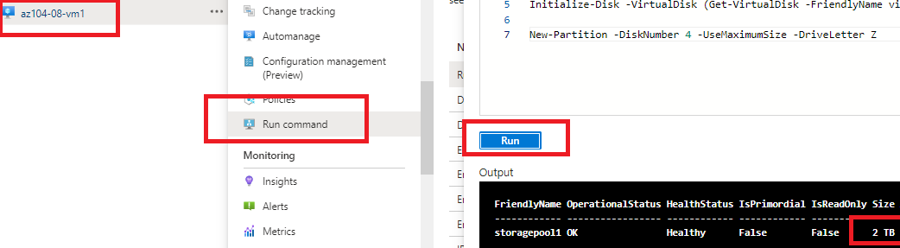

#### **Task 4: Register the Microsoft.Insights and Microsoft.AlertsManagement resource provider**

* 1. In the Azure portal, open the **Azure Cloud Shell** by clicking on the icon in the top right of the Azure Portal.
  2. If prompted to select either **Bash** or **PowerShell**, select **PowerShell**.
  3. From the Cloud Shell pane, run the following to register the Microsoft.Insights and Microsoft.AlertsManagement resource providers.

*Register-AzResourceProvider -ProviderNamespace Microsoft.Insights*

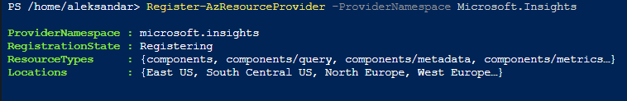

*Register-AzResourceProvider -ProviderNamespace Microsoft.AlertsManagement*

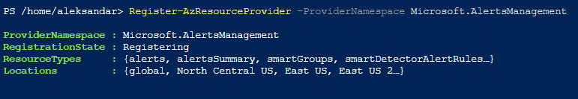

#### **Task 5: Deploy zone-resilient Azure virtual machine scale sets by using the Azure portal**

***In this task, you will deploy Azure virtual machine scale set across availability zones by using the Azure portal.***

1. In the Azure portal, search for and select **Virtual machine scale sets** and, on the **Virtual machine scale sets** blade, click **+ Add** (or **+ Create**).
2. On the **Basics** tab of the **Create a virtual machine scale set** blade, specify the following settings (leave others with their default values) and click **Next : Disks >**:
3. On the **New container** blade, specify the following settings (leave others with their default values) and click **Create**:

|  |  |
| --- | --- |
| Setting | Value |
| Name | **scripts** |
| Public access level | **Private (no anonymous access**) |

1. Back on the storage account blade displaying the list of containers, click **scripts**.
2. On the **scripts** blade, click **Upload**.
3. On the **Upload blob** blade, click the folder icon, in the **Open** dialog box, navigate to the **\Allfiles\Labs\08** folder, select **az104-08-install_IIS.ps1**, click **Open**, and back on the **Upload blob** blade, click **Upload**.
4. In the Azure portal, navigate back to the **Virtual machine scale sets** blade and click **az10408vmss0**.
5. On the **az10408vmss0** blade, in the **Settings** section, click **Extensions and applications**, and the click **+ Add**.
6. On the **New resource** blade, click **Custom Script Extension** and then click **Next**.
7. From the **Install extension** blade, **Browse** to and **Select** the **az104-08-install_IIS.ps1** script that was uploaded to the **scripts** container in the storage account earlier in this task, and then click **Create**.

**Note**: Wait for the installation of the extension to complete before proceeding to the next step.

1. In the **Settings** section of the **az10408vmss0** blade, click **Instances**, select the checkboxes next to the two instances of the virtual machine scale set, click **Upgrade**, and then, when prompted for confirmation, click **Yes**.

**Note**: Wait for the upgrade to complete before proceeding to the next step.

1. In the Azure portal, search for and select **Load balancers** and, in the list of load balancers, click **az10408vmss0-lb**.
2. On the **az10408vmss0-lb** blade, note the value of the **Public IP address** assigned to the frontend of the load balancer, open an new browser tab, and navigate to that IP address.

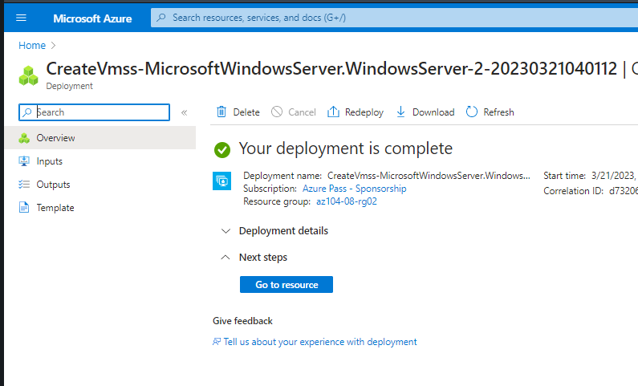

#### **Task 6: Configure Azure virtual machine scale sets by using virtual machine extensions**

*In this task, you will install Windows Server Web Server role on the instances of the Azure virtual machine scale set you deployed in the previous task by using the Custom Script virtual machine extension.*

1. In the Azure portal, search for and select **Storage accounts** and, on the **Storage accounts** blade, click the entry representing the diagnostics storage account you created in the previous task.
2. On the storage account blade, in the **Data Storage** section, click **Containers** and then click **+ Container**.
3. On the **New container** blade, specify the following settings (leave others with their default values) and click **Create**:

|  |  |
| --- | --- |
| Setting | Value |
| Name | **scripts** |
| Public access level | **Private (no anonymous access**) |

1. Back on the storage account blade displaying the list of containers, click **scripts**.
2. On the **scripts** blade, click **Upload**.
3. On the **Upload blob** blade, click the folder icon, in the **Open** dialog box, navigate to the **\Allfiles\Labs\08** folder, select **az104-08-install_IIS.ps1**, click **Open**, and back on the **Upload blob** blade, click **Upload**.
4. In the Azure portal, navigate back to the **Virtual machine scale sets** blade and click **az10408vmss0**.
5. On the **az10408vmss0** blade, in the **Settings** section, click **Extensions and applications**, and the click **+ Add**.
6. On the **New resource** blade, click **Custom Script Extension** and then click **Next**.
7. From the **Install extension** blade, **Browse** to and **Select** the **az104-08-install_IIS.ps1** script that was uploaded to the **scripts** container in the storage account earlier in this task, and then click **Create**.

**Note**: Wait for the installation of the extension to complete before proceeding to the next step.

1. In the **Settings** section of the **az10408vmss0** blade, click **Instances**, select the checkboxes next to the two instances of the virtual machine scale set, click **Upgrade**, and then, when prompted for confirmation, click **Yes**.

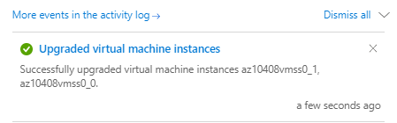

1. In the Azure portal, search for and select **Load balancers** and, in the list of load balancers, click **az10408vmss0-lb**.
2. On the **az10408vmss0-lb** blade, note the value of the **Public IP address** assigned to the frontend of the load balancer, open an new browser tab, and navigate to that IP address.

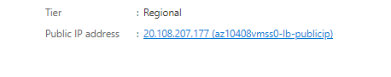

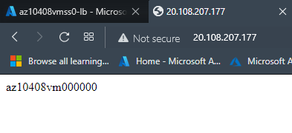

## **Task 7: Scale compute and storage for Azure virtual machine scale sets (optional)**

**In this task, you will change the size of virtual machine scale set instances, configure their autoscaling settings, and attach disks to them.**

1. In the Azure portal, search for and select **Virtual machine scale sets** and select the **az10408vmss0** scale set
2. In the **az10408vmss0** blade, in the **Settings** section, click **Size**.
3. In the list of available sizes, select **Standard DS1_v2** and click **Resize**.

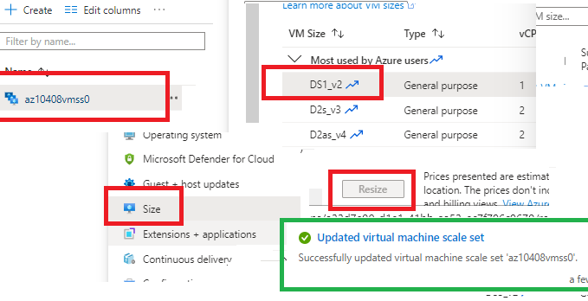

1. In the **Settings** section, click **Instances**, select the checkboxes next to the two instances of the virtual machine scale set, click **Upgrade**, and then, when prompted for confirmation, click **Yes**.

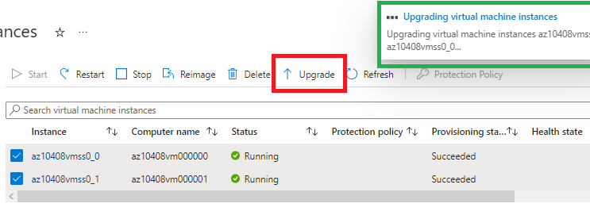

1. In the list of instances, click the entry representing the first instance and, on the scale set instance blade, note its **Location** (it should be one of the zones in the target Azure region into which you deployed the Azure virtual machine scale set).

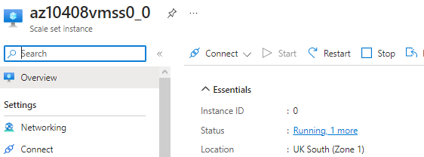

1. Return to the **az10408vmss0 - Instances** blade, click the entry representing the second instance and, on the scale set instance blade, note its **Location** (it should be one of the other two zones in the target Azure region into which you deployed the Azure virtual machine scale set).

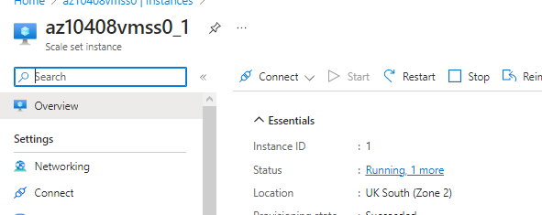

1. Return to the **az10408vmss0 - Instances** blade, and in the **Settings** section, click **Scaling**.
2. On the **az10408vmss0 - Scaling** blade, select the **Custom autoscale** option and configure autoscale with the following settings (leave others with their default values):

|  |  |
| --- | --- |
| Setting | Value |
| Scale mode | **Scale based on a metric** |

1. Click the **+ Add a rule** link and, on the **Scale rule** blade, specify the following settings (leave others with their default values):

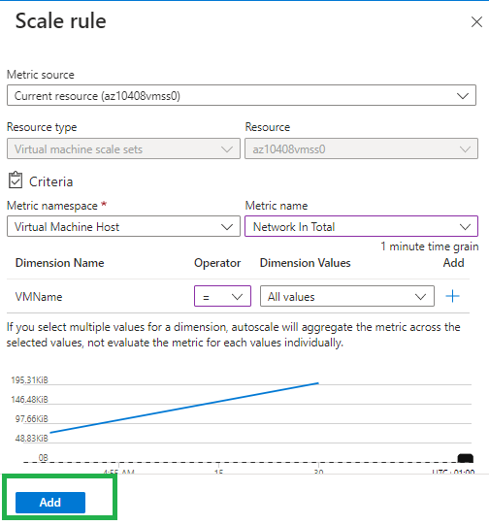

1. Click **Add** and, back on the **az10408vmss0 - Scaling** blade, specify the following settings (leave others with their default values):

|  |  |
| --- | --- |
| Setting | Value |
| Instance limits Minimum | **1** |
| Instance limits Maximum | **3** |
| Instance limits Default | **1** |

1. Click **Save**.

